Cómo escapar las comillas literales en cadenas de texto
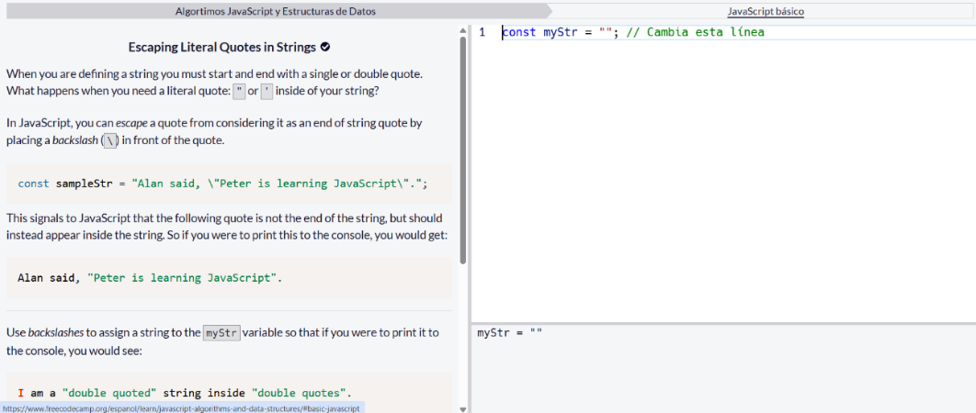

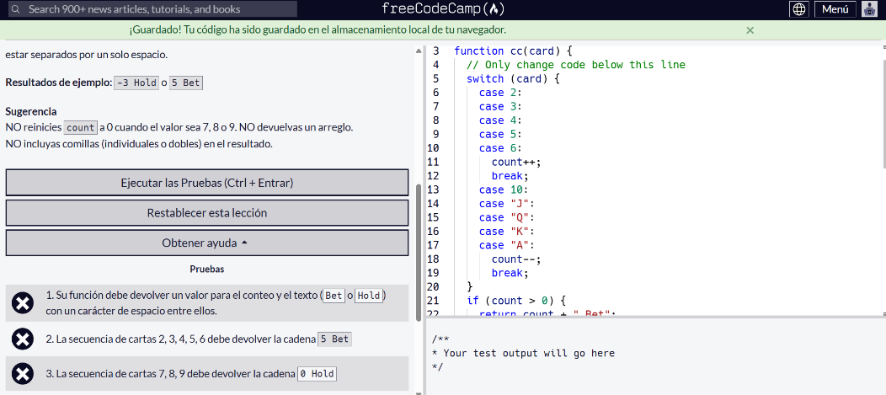

let count = 0;

function cc(card) {
// Only change code below this line
switch (card) {
case 2:
case 3:
case 4:
case 5:
case 6:
count++;
break;
case 10:
case "J":
case "Q":
case "K":
case "A":
count--;
break;
}
if (count > 0) {
return count + " Bet";
} else {
return count + " Hold";
}
// Only change code above this line
}

cc(2); cc(3); cc(7); cc('K'); cc('A');

